

**MARKING GUIDE**

P250/2

**GEOGRAPHY**

**SECTION A**

**STATISTICS (COMPULSORY)**

1. Study the table below showing wind speed and direction and answer questions that follow:

|  |  |  |  |  |  |  |  |  |
| --- | --- | --- | --- | --- | --- | --- | --- | --- |
| **Wind speed** | **Wind direction by Percentage** | | | | | | | |
| **N** | **NE** | **E** | **SE** | **S** | **SW** | **W** | **NW** |
| Less than 4mph | 1.3 | 3.2 | 2.6 | 3.4 | 2.2 | 4.6 | 2.0 | 3.6 |
| 4 – 12 mph | 2.4 | 4.0 | 3.1 | 2.8 | 1.7 | 4.4 | 3.5 | 2.5 |
| 13 – 24 mph | 1.6 | 4.5 | 3.6 | 3.9 | 1.4 | 3.7 | 1.0 | 2.1 |
| More than 24 mph | 0.8 | 2.5 | 2.6 | 1.5 | 0.8 | 3.4 | 0.3 | 1.0 |
| **Total** | **6.1** | **14.2** | **11.9** | **11.6** | **6.1** | **16.1** | **6.8** | **9.2** |

***Calms 18.0***

***Adapted from statistics by Truranppg. 38.***

***Candidates will need a cumulative table for easy drawing***

*No mark is allocated for the cumulative table*

**Questions**

1. Draw a Compound Wind Rose to represent the information in the table above. (12 marks)

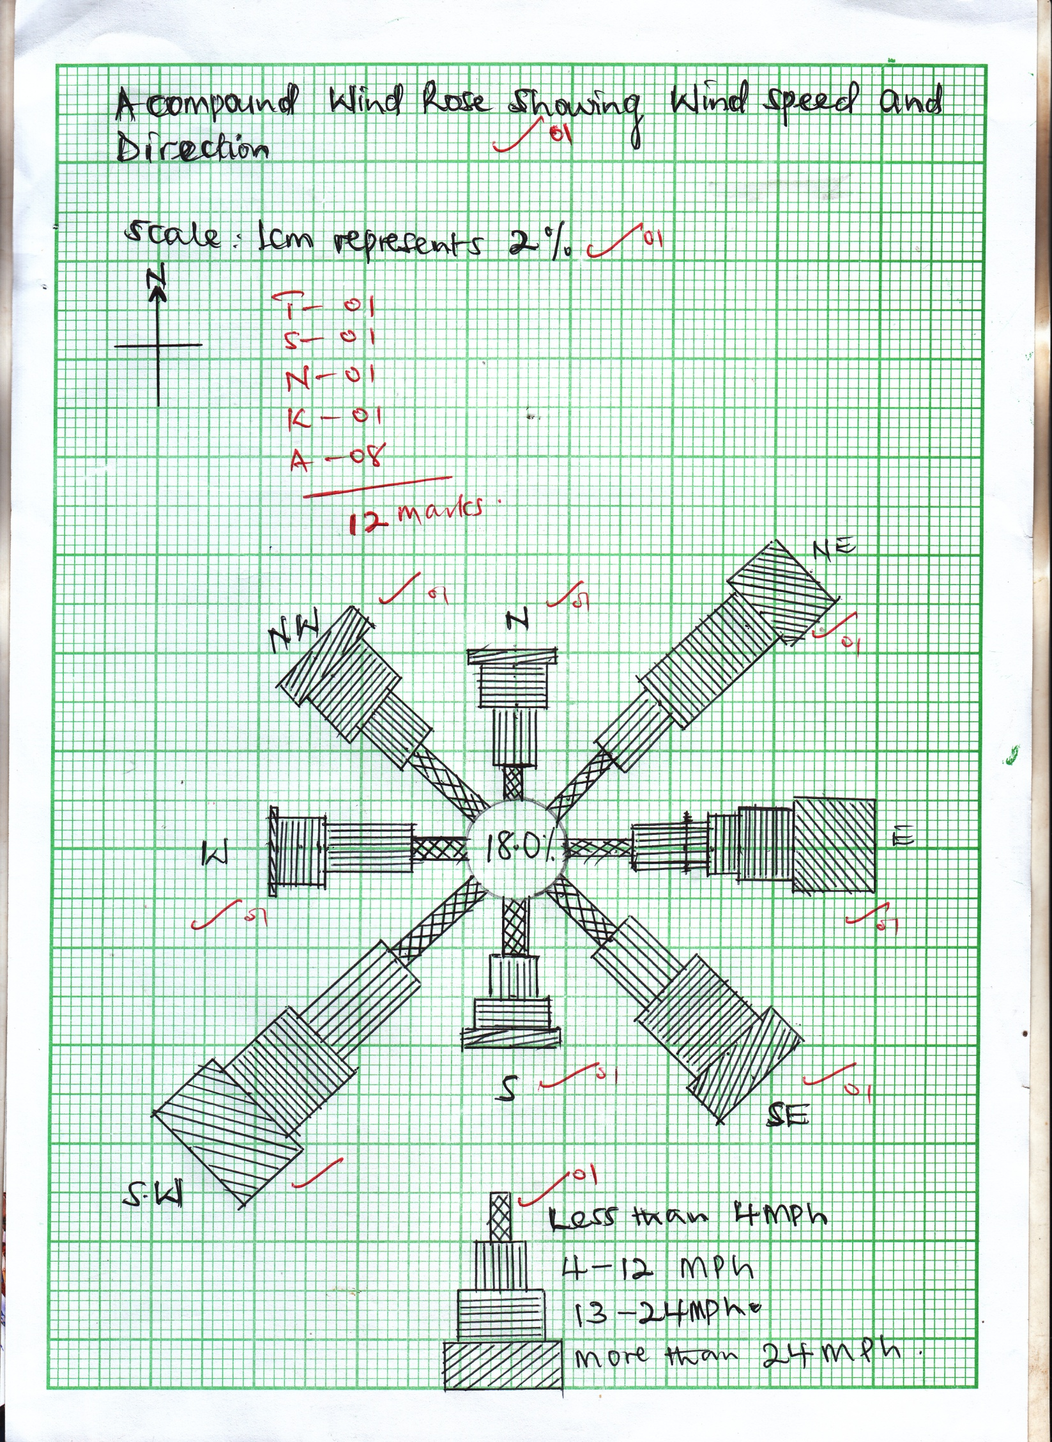

1. Outline the advantages and disadvantages of the above statistical chart.

(05 marks)

*Candidates should give the advantages and disadvantages of a wind rose. (Compound)*

***Advantages***

* *Easy to draw*
* *Visual impression due to use of colours*
* *Shows a lot of information*
* *Easy to read*
* *It’s a absolute method of wind speed and direction*

*Any 3 x 1 = 03 marks)*

***Disadvantages***

* *Limited to only wind speed and direction*
* *Takes a lot of time*
* *Takes a lot of space*
* *Its tiresome*
* *Looks crowded*
* *Hard to interprete*

*Any two x 1 = 2 marks total marks = 5 marks*

1. Discuss the effects of wind on the development of agriculture in Zambia.

(08 marks)

***Positive effects***

* *Leads to frontal rainfall formation*
* *Helps in pollination*
* *Helps in seed dispersion*
* *Wet winds cause rainfall*
* *Generated energy forexample wind energy for processing the produce*
* *Used in cleaning up the produce though winnowing*

*Any 5 x 1 = 5 marks*

***Negative effects***

* *Causes soil erosion hence loss of the top fertile soils*
* *Leads to damaging of crops like bananas, coffee trees, etc*
* *Dry winds cause drought hence crop failure.*
* *Accelerate the spread of fire*

*Any 3 x 1 = 3 marks*

**SECTION B**

Answer ***three*** questions from here

1. (a) Distinguish between plantation farming and extensive farming. (10 marks)

*Marking is by impression*

*Candidates are expected to write down the differences between plantation farming and extensive farming*

*Candidates can use any of the known formats of differentiation. And should use the differentiating terms like;*

* *While*
* *Where as*
* *Yet*
* *On the other hand*
* *Etc*

*Short of these, no marks at all, except for the one used here.*

|  |  |
| --- | --- |
| ***Plantation farming*** | ***Extensive farming*** |
| * *This is the growing of a single perennial crop on a very large scale using scientific methods for commercial purposes e.g sugar cane in South Africa etc* * *Only crops involved* * *Perennial cropping* * *Both capital and labour intensive* * *Common in tropical areas* * *Requires heavy and reliable rainfall through out the year* * *Deep and fertile soils are required* | * *This is the growing of a single annual crop or the rearing of animals on a large scale using scientific means for commercial purpose e.g. Pampas in Argentina, Wheat in the prairies* * *Can be a crop or animals* * *Annual cropping* * *Largely capital intensive for the crops i.e. machines can be used from planting to harvesting* * *Common in savanah grass land areas* * *Moderate rainfall of 1000mm and below with clear dry seasons is required* * *Soils are moderately fertile* |

(b) Discuss the physical conditions responsible for the development of plantation farming in Liberia. (15 marks)

*Candidates may omit the definition for plantation farming but focus on the details of plantations in Liberia.*

*Liberia is located in the north west of Africa with access to the Atlantic ocean. The plantation crop have is rubber. There are mainly two rubber plantations i.e. the herbal rubber plantation which is the biggest and believed to be the biggest single rubber plantation in the world. It is located north west of Monrovia and the cavalla rubber plantation located in the west of Liberia. (one may draw a sketch map of Liberia showing the plantations – no particular mark is assigned for the sketch map – its part of impression building)*

*Factors : These should be physical only*

* *Presence of fertile soils*
* *Presence of large expanses of land*
* *Presence of rivers providing water for irrigation in the dry seasons to supplement on the heavy rains e.g. river St. Paul, Cavalla river, Fermington river etc*
* *The gently sloping relief from north east to south west enabling mechanization, irrigation and construction of roads.*
* *Low incidence of pests and disease carrying vectors*
* *Variety of rubber tress e.g. Have abrasiliensis which are high yielding and resistant to pests and diseases.*
* *Temperatures should constantly be 27oc (80oF) on average and never below 21oC (70oF)*
* *Rainfall of over 1500mm per year and coming throughout the year*

1. To what extent have physical factors influenced the development of marine fishing in either Japan or Morocco? (25 marks)

*Candidates are expected to choose one country or case study*

* *Define marine fishing and briefly talk about the fishing industry in the country chosen*
* *One may draw a sketch map showing the fishing grounds or areas and the fish landing ports*

***Either Japan***

*Marine fishing refers to the extraction of aquatic animals from oceans and seas.*

*Japan carries out her fishing in tehnorth western pacific fishing ground, in the waters of sea of Japan. Yellow sea, sea of Okhotsk, and the pacific in the east of the country. The fish landing sites or ports include; Sapporo, Tokyo, Kyoto, Osaka, Kobe, Kitakyushu, Nagaski, Kawasaki, Yokohama, Nagoya, etc.*

*The fish species include; tuna, Mackrel, Yellow tail fish, salmon fish, cuttle fish, sardines, herding, shellfish, and crustaceans especially the crabs and lobsters. Common methods of fishing include; trawling, seining, lining and drifting.*

***OR Morocco***

*Carries out her fishing in the North east Atlantic fishing ground in the waters of Mediteranean Sea, straight of Gibraltar and Atlantic Ocean. The fish landing sites include; Tarfaya, sidilfini, Tiznit, Agadir, Essaouira, Safi, Eljadida, Casablanca, Rabat, Kenitra, KAsr el kebir, Larache, Tangier, Ceuta, Nador, and Melilla.*

*Fish species Tuna, Mackerel, salmon, sardine, etc fishing methods, - trawling, seining, lining and drifting.*

*Candidates should begin with physical factors such as;*

* *Long coast line*
* *Shallow and extensive continental shelf*
* *Variety of fish species*
* *Cool climate of less than 21oC temperatures*
* *Effect of ocean currents (warm kuro – shio and cold oya – shio for Japan) and (the north Atlantic drift for Morocco)*
* *Clear waters of the ocean*
* *Plenty of phytoplanktons on which the fish feeds*
* *Presence of natural harbours*
* *Highly indented coastline / highly fiorded coast line (for Japan) with off shore islands providing sheltered waters and good sites for development of fishing ports or villages*
* *Poor agricultural resources driving people to fishing / (rugged terrain)*
* *Limited natural resources like minerals and the limited fertile soils.*
* *Limited sources of proteins*
* *Presence of forest providing timber for ship building*
* *Locational advantage in the northern hemisphere with cool waters*
* *Smooth sea bed for easy use trawling method of fishing*

***However, there are other factors such as;***

* *The long sea faring tradition dating far back*
* *Most settlements are on or near the coast and their activities are marine oriented*
* *Adequate / large sums of capital available for investment in the fishing industry*
* *Presence of abundant and fairly cheap labour with long history and experience in fishing.*
* *Advanced technology used e.g.fish tracking at night processing of fish in the fishing waters etc*
* *High levels of mari – culture with many research centres*
* *Efficient and modern transport links*
* *Presence of many fish processing, factories,*
* *The long established ship building industry*
* *Existence of ready market both at home and abroad*
* *Favourable government policy*
* *The advanced and commercial fishing methods used.*
* *The advanced and commercial preservation methods used.*
* *Existance of storage facilities*
* *Good international relationships*
* *Presence of power and energy for the processing and fish preservation*
* *Political stability*

*NB: The candidate should clearly indicate / how when crossing to the other side*

*of the question using terms like however, on the other hand etc*

*No transition statement in the other part of the answers becomes invalid.*

*No sorting for candidates.*

*Marking is by impression. (25 marks)*

1. Examine the factors for population density variations in either Egypt or Canada.

(25 marks)

* *Candidates should choose one country*
* *Define the term population density*
* *Give an over view of population density of the chosen country clearly showing the variations*
* *One may draw a sketch map of the population variations*
* *Then give the factors stating netral factors*

*Population density refers population per unit area. The population density of a given area is either high, moderate or low.*

***Either Egypt***

*This has a total population of over 96 million. This population is highly concentrated in a small or narrow area around the Nile and Nile delta. Also high population densities are found in the urban centres which also are found in the Nile valley and Delta e.g. in Cairo, Port Said, Alexandria, El – minya, Aswan, Mallawi, Luxor, Tahta, Tanta, Samalutetc*

*Moderate population densities are found around oases like Qattara, Siwa, Tarfaw, Farafra and the coastal areas of the red sea.*

*The rest of the areas have nil populations like, the Great sand sea.*

*Sparsely populated areas like the western difficult Libyan Desert*

***CANADA***

*Has a total of over 38 million people. Over 38 million people. Over 90 percent of this population lives in a narrow strip in the south at the boarder with USA in a narrow belt of not more than 320km (200 miles) wide with the St. Lawrence low lands being density together with the Atlantic and pacific coastal areas in the provinces of Ontario, Quebec, then British Columbia an dalberta populated while the prairies and maritime provinces are moderately population*

*The urban centres of Edmonton, Calgary, Regina, Winnipeg, Thunder bay Toronto, Ottawa, Montreal and Quebec are also density populated.*

*The northlands have remained sparcely or not settled at all except the areas occupied by the original inhabitants the Eskimos.*

*The variations in the density is due to;*

* *The nature of climate of the areas*
* *The fertility of the land or soils*
* *The influence of / nearness to water bodies*
* *The variations in the vegetation of the area*
* *Historical factors*
* *Prevailing political climate*
* *Influence of transport and communication links*
* *Urbanization effect*
* *Industrial development*
* *Nature of relief*
* *Variations in altitude*
* *Variations in biotic factor incidence*
* *Influence in drainage*
* *Existence of minerals and other natural resources*
* *Effect of fishing activities*
* *The influence of trade and commerce*
* *The influence of government policy*
* *Etc*

*NB: Points should be state in a mutual form.*

*Marking is by impression (25 marks)*

1. Explain the impact of mining on the environment of either the Rand Mineral Complex of South Africa or the Great Lakes Region of U.S.A. (25 marks)

*Candidate should choose a case study*

*Should define mining, identify the mining centres and the minerals and any other information*

***Either***

*The Rand mineral complex of South Africa*

*Diamond at Kimberly and Johaneesburgh, Gold at Johannesburgh, Bloemfontein, Klerkdor, Coal at vernninging, vanderbirjl, iron ore at thabazimbi, etc other minerals include, copper, zinc, lead, uranium, tin, cobalt, silver etc*

***OR***

*The great lakes region of USA*

* *Oil in the Appalachian mountains, iron ore at Duluth (lake superior area) Masabi ranges, Appalachian, coal from Appalachian, mesabi ranges, manganese, copper, cobalt around lake Huron region, oil, coal lead in the Pittsburgh areas etc*

***Positive impact***

* *Source of employment*
* *Source of government revenue*
* *Source of foreign exchange through exporting the minerals*
* *Helped to diversify the economy*
* *Promoted industrial development by providing raw materials*
* *It has promoted urban development*
* *It has promoted the development of mining skills*
* *It has promoted research and education*
* *It has promoted the development of the tourism sectors*
* *Improved on the transport and communication sector in a bid to help access the minerals and processing centres.*
* *Improved on international relationship with other countries*
* *The sector has improved on the social economic services offered in the mining areas*
* *Mining has led to accumulation of capital through the sale of minerals like gold, oil etc*

***Negatives***

* *It has created regional imbalance in development*
* *It has promoted profit repatriation since many mining firms are foreign multi – national cooperation.*
* *Has greatly polluted the environment.*
* *Open cast method of mining has led to damaging of the land surface creating bad or ugly lands.*
* *It promotes (open cast) environmental degradation.*
* *It creates depression where water collects hence forming breeding grounds for diseases carrying vectors.*
* *It is associated with a lot of accidents*
* *It has promoted rural urban migration*
* *It has promoted the occurrence of soil erosion*
* *Has diverted labour and capital from other sectors hence affecting their rate of development*

*Marking is by impression. (25 marks)*

1. With specific examples from either Tanzania or Switzerland, examine the problems facing the tourism industry. (25 marks)

* *Candidates should choose a case study*
* *Should define tourism and identify the tourism bases / attractions*

*Tourism is the movement of people from their places of origin to destination areas or research, education, out of curiosity etc at a fee.*

*Tourism in Tanzania*

* *The main basis is wildlife with national parks like Serengeti, Ruaha, Kilimanjaro, Mikumi, Katafi, Tarangire, Ugalla, Ngorongoro, Mukomazi, etc*
* *Relief features like mountains such as Kilimanjaro, Usambar, Ngorongoro (an active volcano) the eastern and western arms of the rift valley, etc*
* *Drainage features like L. Malawi, Victoria, Manyara, Tanganyika, rivers like Rufigi, Ruvuma, the Indian ocean and its associated features etc*
* *Historical sites like old Vai George, Isimiliaston age, the National meseum at Dar – essalametc*

***OR***

***Switzerland***

* *Some of the tourism centres include the Apine winter resorts such as Grindelwald, Gistand, St, Meritzetc other centres include; the national parks like the Geneva, the central Swiss National park. The Bussel; Zoo etc the bear exhibition / Brussel’s carnival the Swiss alps (Alpine mountains) Drainage features such as L. Constance. L. Geneva, Rivers such as the Rhine river, R. aaretc*
* *The rivers have waterfalls and pronounce gorges. Also important are the Geneva summer summit, outstanding urban centres, such as Brussels, Geneva, Winter resort centres, Zurich etc*

***Problems***

* *Limited tourist attractions*
* *Hostile tribes, environment etc*
* *Limited or costly advertisement*
* *Poorly developed transport or innaccesible tourist attratios*
* *Limited capital*
* *Limited international languages*
* *Political instability*
* *Insecurity at the different tourist attractions*
* *Corruption and embezzlement of funds*
* *Competition for land with other economic sectors*
* *Limited labour force*
* *Increasing poaching of wild game*
* *Death of wild animals*
* *Bush burning by the local and neibouring communities and game wardens*
* *Wild bush fires common in savannah and grass land areas*
* *Limited technology*
* *Limited research*
* *Unfavourable government policies*
* *The effect of climatic changes*
* *Inadequate or costly accommodation facilities*
* *Limited power and energy sources at some remote tourist attractions*
* *Limited auxillary services to easy movement of funds by tourists*
* *Limited tour and travel companies*
* *High level of poverty affecting local tourism*
* *Disease out breaks like the COVID – 19 pandemic*
* *Effects of economic depression*
* *Fear created by terrorist activities*
* *Poor health facilities to handle emergencies.*

*NB: the problems faced by Switzeland may differ from those of Tanzania*

*The diference may also be seen in the explanation*

*Marking is by impression (25 marks)*

1. Assess the contribution of the Suez Canal to the development of the region.

(25 marks)

***Approach***

* *Candidates are expected to;*
* *Locate the Suez canal and briefly talk about it*
* *Look at the positive and negative contributions of the canal*

*The Suez canal links Europe with the far east. It runs from port said on the Mediterranean sea to suez at the gulf of Suez on the red sea, a distance of 152 km (101 miles) with a depth of 10m (33 feet) and a tonnage limit of 20,000 tonnes. It is the longest canal without locks. It was constructed in 1869. Commodities to Europe include, oil, cotoon, tea, coffee, sugar, rubber, tin, dates, silk, teak, spices, tobacco, tempwool, wheat, meat, hides, fruits etc.*

*Commodities to the far East include; manufactured goods, textiles, chemicals, machinery, paper, automobiles, fertilizers etc*

***Positive contributions***

* *Provided low cost and efficient means of transport e.g. 5.5% of world out put of oil passes through the canal*
* *Shortened the cape of good hope route by 6400 km (4,000 miles) between Liverpool in Britain (Europe) and Colombo in India (for east)*
* *Development of industries through importation of raw materials like agricultural produce and providing market for the manufactured goods from Europe*
* *Created access route to market centres of Europe and the far East.*
* *Promoted employment opportunities*
* *Led to development of towns such as El Qantara, Isimailia, the Suez, port said, port Tawfiq, El Firdan,*
* *Source of water for domestic and industrial use and the water pipeline to Sinai.*
* *Source of foreign exchange through the tariffs paid by the foreign ships.*
* *Led to development of other forms of transport e.g. the railway line running in length parallel to its west bank.*
* *It is a source of revenue or created a wide tax base through tolls*
* *Promoted international trade with large volumes of imports and exports. 50 ships pass through the canal daily.*
* *Promoted the development of agriculture in the far East and on the Sinai peninsular*
* *Promoted regional and international cooperation*
* *Dramatically reduced the transit time to 12 hours as a bypass between Europe and Asia. This saved time, fuel and ship operation costs.*
* *Promoted foreign investments in Egypt brininging in foreign capital inflow.*
* *It enlarged port Said’s hinterland and trade volume hence its fast development*
* *It promoted natural resources exploitation for minerals like oil and agricultural resources in the far East.*
* *Helped to diversify the economy of Egypt and a number of countries in the far East.*
* *Promoted the development of tourism in Egypt and far east.*
* *It boosted marine studied and research e.g. the Suez canal authority research centre.*
* *There are almost no accidents on the Suez Canal compared to the other water ways.*

***Negatives***

* *Severe pollution due to oil spills, collisios of oil tankers and industrial wastes at port said and Suez.*
* *Led to growth of towns and their negative effects*
* *The taxes paid by the foreign ships are high making the commodies carried through the canal expensive*
* *The canal is narrow and therefore can easily be blocked for traffic hence considered a geographical check point.*
* *It takes about 12 hours to go through the canal and the sped must be low to avoid erosion of the canal banks by ship water waves.*
* *The canal closed several times in the 1960s and 1970s due to conflicts between Egypt and Israel.*
* *The creation of Israel in 1948, created a lot of trouble for the canal since Egypt never wanted Israel.*
* *It has a problem of pirates*
* *Super tankers can not use the canal because its narrow.*
* *The canal workers have several times complained of low pay*
* *Silting of the canal*

*NB: marking is by impression (25 marks)*

1. Account for the increasing levels of pollution in either China or U.S.A. (25 marks)

*Pollution can be defined as increase in the impurities into the environment*

*The areas of pollution include the mines, urban centres, water bodies etc*

***Either***

*Pollution areas of USA include;*

*Mining centres like Appalachian, Great lakes region, Messabi ranges, Kentucky areas, New York, California’s central valley and northern areas;*

*The industrial areas of New York, Philadelphia, Baltimore, Chicago, Pittsburgh areas, Boston etc, water bodies like Hudson river, St. Lawrence river, the Great lakes, river Colorado etc*

***Or***

*China’s areas of pollution*

* *Industrial areas of Manchuria, Beijing, Wuhan, shanghai, Hongkong, Shanxi – Boutou region, lower (hang – Tiang (Yangtze – Kiarg) region, Sikiang delta at port Guanzhou, Sichuan region etc*
* *Mining of Shanxi, Manchuria, Beijing, hubei, Xi – jiang region etc, water bodies like Yangtse, Sikiang river, Xi river, Yellow river etc.*
* *Pollution is in different forms which the candidate should be able to point out e.g. noise pollution, land or soil pollution , water pollution, and air pollution etc*

***Causes***

* *Loud music played in urban centres*
* *Noise from the air crafts as they take off or land*
* *Industries make a lot of noise*
* *Mining or rock blasting*
* *Leaving of huge open mines un covered*
* *Dumping of toxic wastes like nnclear wastes*
* *Sewage discharge on the lands surface*
* *Improper disporsal of garbage.*
* *Dumping of plastic and polythene materials*
* *Discharging of industrial wastes*
* *Un treated sewage disposal*
* *Oil spills*
* *Chemical fertilizers and mining bi - products*
* *Heavy industrialization*
* *Burning of fossil fuels*
* *Dust storms*
* *Use of fertilizers / pesticides*
* *Use of weed killers / herbicides*
* *Use of human wastes as fertilizers*
* *Irrigation / salination*
* *Testing nuclear weapons*
* *Use of ammunitions*

*Impressional marking (25 marks)*

**END**